Instructions for participating in the language proficiency test

To authenticate, please have the Zoom Us (https://zoom.us/) application installed on your phone/tablet / computer and have prepared an identity document (you will have to show it before the exam).

Access to the Zoom.us platform will be allowed starting at 8:15, to authenticate the participation in the language proficiency exam. Authentication will be performed both video and audio, throughout the exam.
Lack of identification on Zoom will be considered an absence from the language proficiency test.
Zoom access link:
Access link: ... will be announced before the examination
At 9:00, access to the test will be allowed on the online.ase.ro platform.
You will log in on https://online.ase.ro/login/index.php with your username (email address) and password (the ones you chose on the enrollment platform).
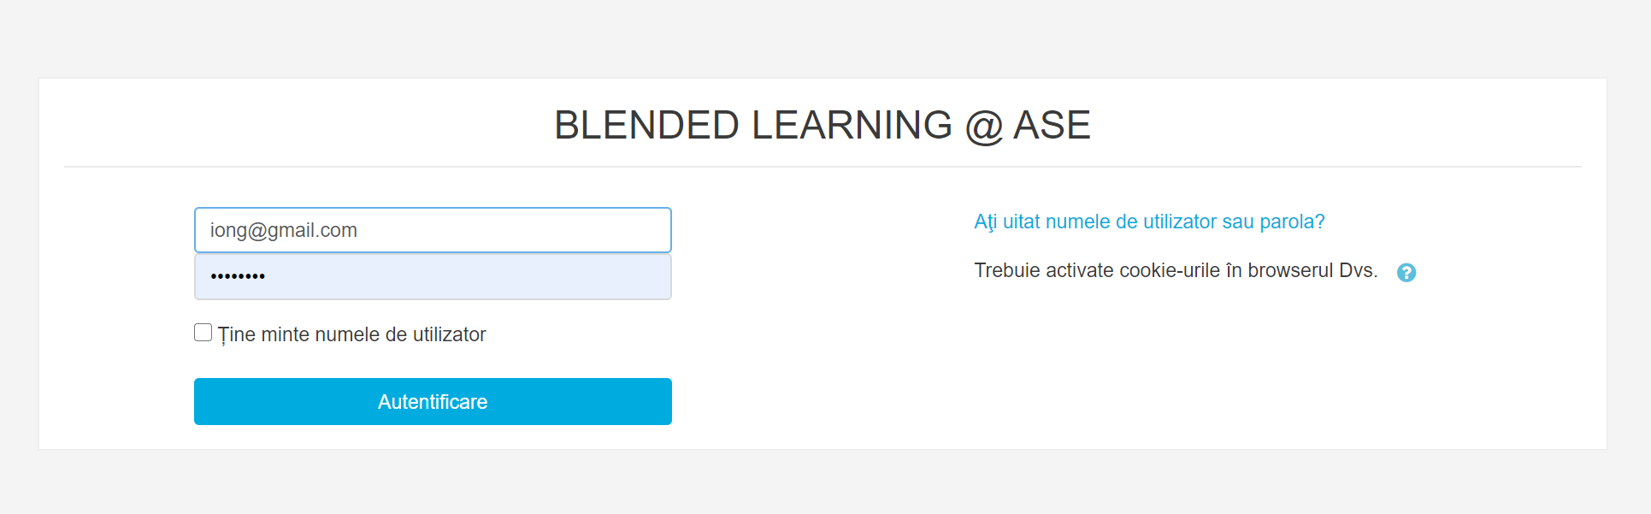
After authentication, you will select the course related to the foreign language in which you take the exam (English for economic studies, French for economic studies, English for legal studies, French for legal studies).
The test with multi-choice quizzes will be available from 9:00 to 11:00. It can only be taken once.
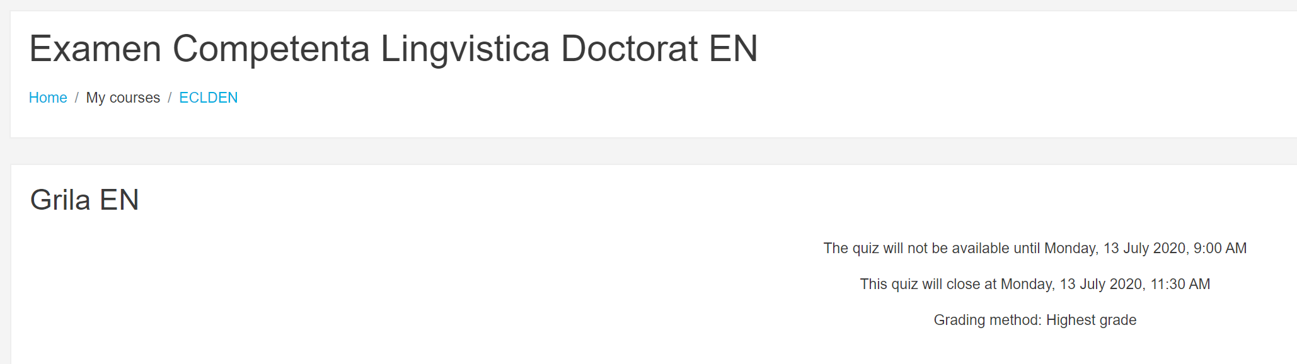
There will be 30 questions with 4 answers to choose from. The questions have only one correct answer.
The most important elements of the screen:
1. Available time;
2. Next page button that leads to the next question (the answer is saved automatically);
3. Previous page button leading to the previous question;
4. List of questions in the test (those that have not yet been answered are marked with blank borders).
Any problems will be reported via the Zoom platform during the exam. Problems reported after the exam will not be taken into consideration.
